QUALITATIVE STATISTICAL ANALYSIS OF SENIOR WORLD CHAMPIONSHIP 2022 - BELGRADE (SRB)

Milorad Dokmanac, Phd
Sports Academy – Belgrade

INTRODUCTION
By applying a new way of analyzing major world championships (Performance Data Analysis - PDA), a completely different approach is obtained in analyzing the wrestling championship. In the first phase of creating PDA, all video matches at the championship were reviewed and data on all segments of wrestling matches were recorded. In the next phase, a qualitative analysis of the wrestling techniques that were shown at the last senior world championship in 2022 in Belgrade (SRB) was made through a prepared platform called - PDA.

The first steps in the statistical analysis of wrestling matches were made by Prof. Tunnemann, who did pure statistics, without quality analysis of the achieved points. In the past, before the advent of informatics in sports, these analyzes were of great importance to FILA. However, with the advent of the information age, a significant improvement of the wrestling match analysis system has occurred through PDA. The PDA platform provides a completely different "quality dimension" in today's modern wrestling when analyzing wrestling matches.
Based on the data obtained through the prepared Internet PDA platform, we receive exact data on all important elements of wrestling matches. These data are of great importance for at least 7 wrestling subjects, namely:
1. Wrestling coaches,
2. UWW Technical Commission,
3. Wrestling Academy,
4. Media,
5. Scientific commission of UWW,
6. UWW Marketing Commission,
7. Bureau of the UWW.

The PDA analysis contains a total of 12 electronic pages with 34 tables and 29 graphs. Due to the large number of analyzed parameters, only the most important parts of "PDA" were taken for this paper (Belgrade -SRB, Senior WCH 2022), which were presented in a total of 9 units, namely:
1. General data – GR, FS, WW
2. Total points per technical in % (percentage) – GR, FS, WW
3. All matches – standing / parterre points & technical / other points - GR, FS, WW
4. Rewiev all matches points per weight category and wrestling tecnical and other points - GR, FS, WW
5. Efficiency (wq/min) & standing / parterre in % (percentage) & GR, FS, WW
6. Review total % (percentage) by category – tecnical and other points / GR, FS, WW
7. Most successful wrestler (msw) / GR, FS, WW
8. National team performace / points win and points lost / GR, FS, WW
9. Individual wrestlers performance – GR, FS, WW / points win – points lost

In this paper, only the most important parts related to wrestling techniques are given, which are performed by weight categories, by national teams, by individual wrestling techniques, the most successful wrestlers in all three styles are shown, and at the end of the analysis, the techniques for each wrestler are shown (which with which techniques did he win points and with which techniques did he lose points).

Due to the limited space to publish all the details of this analysis, only the most significant details are shown, and the complete analysis can be seen on the platform called "Performance Date Analysis" at the Internet address: http://uww.io/wpar

1. GENERAL DATA / SENIOR WCH 2022. – GR, FS, WW

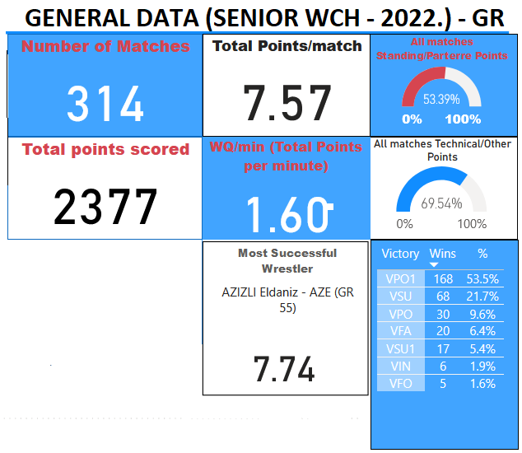 | The most important data from this table of GR style is the number of technical points per 1 minute of the fight. In the GR style it is 1.60 and is the smallest compared to the other two wrestling styles (FS and WW).  One of the reasons for the lower number of technical points in the GR style is because practically a wrestling match lasts 4.5 minutes, since in 70% of matches the first 90 seconds are waiting for the judges jury decision on the pasivity.  Another reason is that the technical fall is 8 points difference, while in FS and WW it is 10 points difference.  There are only 6.4% of fall, and 27.1% of technical fall (VSU and VSU1). Most of the victories were on points (VPO and VPO1) totaling 63.1%  Other important data from this table will be elaborated in the continuation of the analysis.
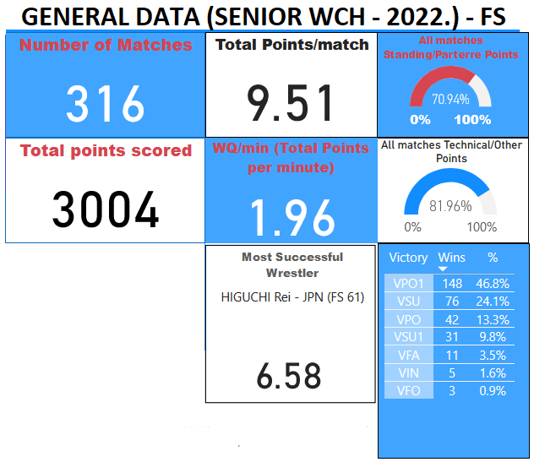 | The number of technical points in FS per 1 minute of the fight is 1.96 and is the highest compared to the other two wrestling styles (GR and WW).  There are only 3.5% of fall and it is the lowest percentage of fall compared to the other two styles.  There are 33.9% of technical fall (VSU and VSU1) and it is the largest in comparison with the other two wrestling styles.  As in the other two styles, most victories were achieved on points (VPO and VPO1) and that is 60.6%.
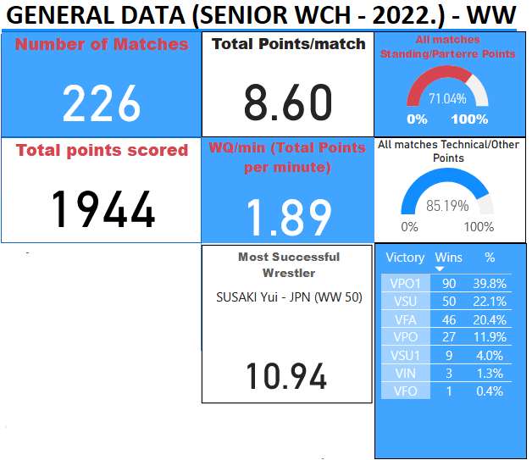 | The number of technical points in WW per 1 minute of fight is 1.89.  There are a lot of fall and there were 20.4% of matches that ended with a fall victory. This is a big difference compared to the other 2 wrestling styles. This data fall that at WCH there was a big difference in the quality of WW compared to the other two wrestling styles (GR and FS).  Technical fall (VSU and VSU1) 26.1% and this number is approximately similar to the other two wrestling styles.  Compared to the other two wrestling styles, the fewest victories were by points (VPO and VPO1) and that was 50.7%, and this is because there were a lot of victories by fall.

2. TOTAL POINTS PER TECHNICAL IN % (Percentage) / SENIOR WCH 2022. – GR, FS, WW

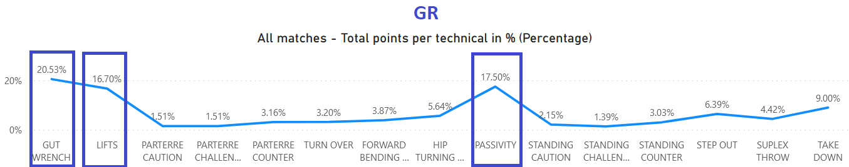

In the GR style, two wrestling techniques and points for passivity are distinguished by the number of points made. The most technical points in the GR style were made with the GUT WRENCH technique, 20.53% and the LIFTS technique – 16.70%. A large number of points were decided by the judges because 17.50% of points were awarded to wrestlers for passivity in the first and second rounds.
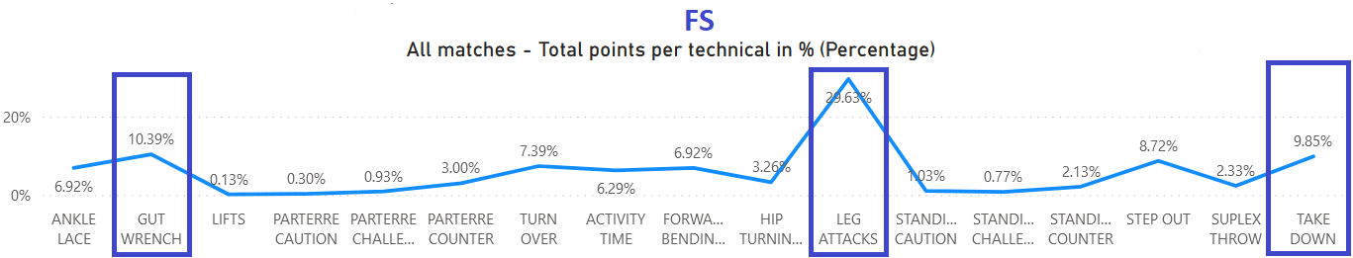

In FS, three wrestling techniques are distinguished by the number of points made. The most technical points in FS were made: 29.63% with the LEG ATTACK technique, 10.39% with the GUT WRENCH technique and 9.85% with the TAKE DOWN technique. Unlike the GR style where passivity is penalized with 17.50%, in FS only 6.29% points are awarded to the ACTIVITY TEAM for passive wrestling in the first and second rounds.
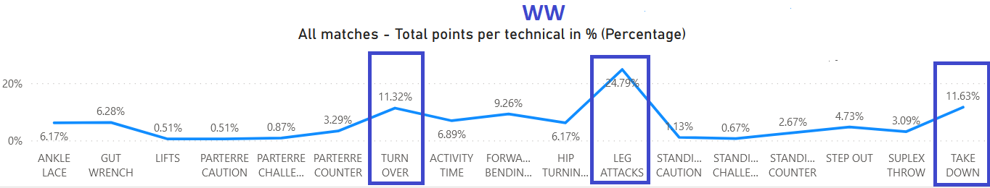

In WW, three wrestling techniques are distinguished by the number of points made. The most technical points in WW were made: 24.79% with the LEG ATTACK technique, 11.63% with the TAKE DOWN technique and 11.32% with the TURN OVER technique. Unlike the GR style where passivity is penalized with 17.50%, in WW only 6.89% points are awarded to the ACTIVITY TEAM for passive wrestling in the first and second rounds.

3. ALL MATCHES – STANDING / PARTERRE POINTS & TECHNICAL / OTHER POINTS & GR, FS, WW

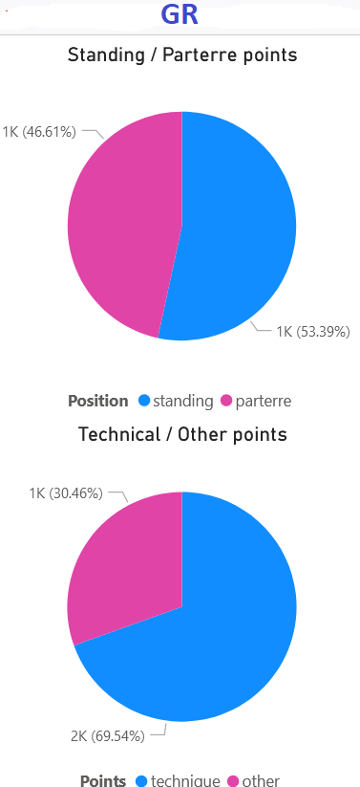 | 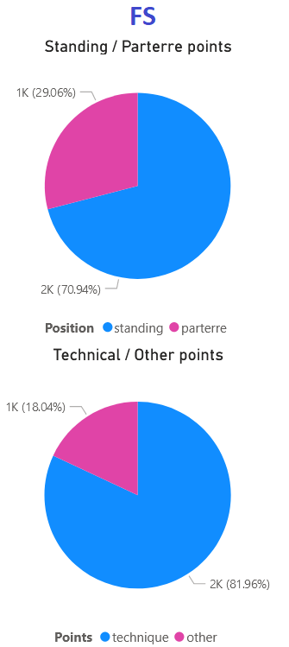 | 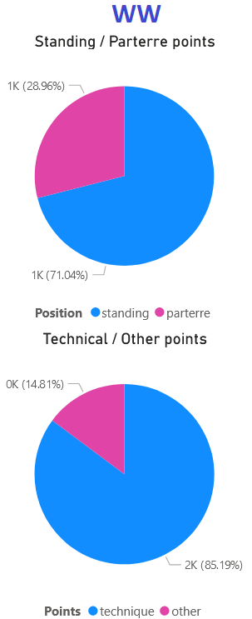
The data in this graph is very significant to see the ratio of points in the standing position to the parterre position and the ratio of technical points to other points.  In the GR style, there is a significant difference compared to the other two styles (FS and WW) because as many as 46.61% of the points were won in the parterrre.  Likewise, the data for the GR style speak of a significant number of other points (points that are not wrestling techniques – passivity, warning, step out, challenge...). In the GR style, almost 1/3 of the points are OTHER POINTS (30.46%).  This information talks about the topic that it is necessary to change something in the wrestling rules to significantly increase the number of points for WRESTLING TECHNIQUES in relation to OTHER POINTS. | In FS, unlike the GR style, the number of points in the parterre is significantly lower. In total, the wrestlers won 29.06% of points with parterre techniques.  In FS and WW, an equal percentage of technical points were made in parterre compared to GR style.  There are significantly fewer points for OTHER POINTS - 18.04% compared to GR style. However, here too, there is a fairly high percentage of points that are not wrestling techniques - activity time. | In WW, the most points were won in the standing position, 71.04%, compared to the other two wrestling styles (FS - 70.94% and 53.39% in GR).  WW has the fewest points for OTHER POINTS (activity time, warning, step out, challenge...). – 14.81% compared to FS and GR style.

4. REWIEV ALL MATCHES POINTS PER WEIGHT CATEGORY AND WRESTLING TECNICAL AND OTHER POINTS& GR, FS, WW

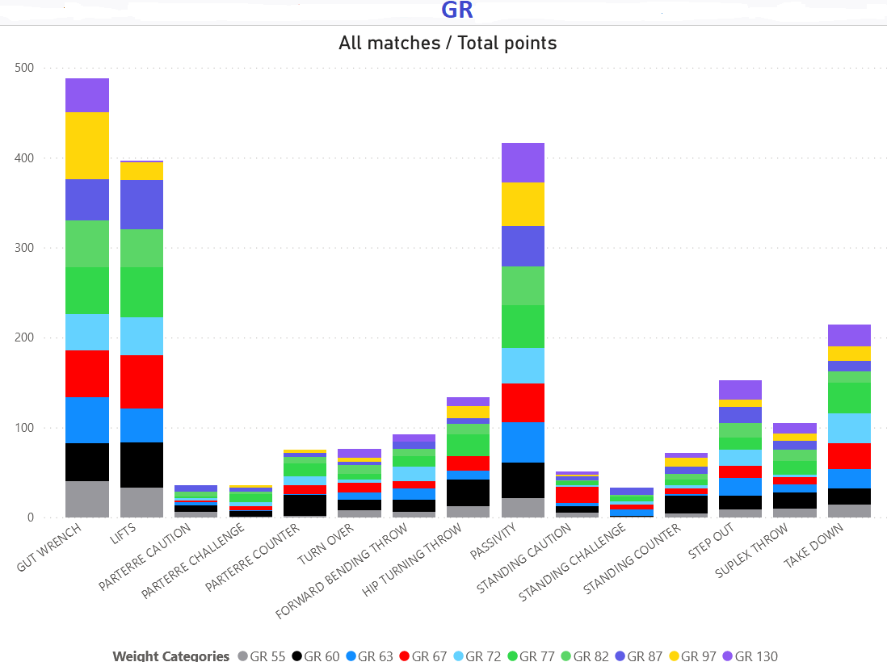 | Analyzing the techniques performed in the GR style by weight categories, it is evident that the most points were scored in 97 kg (74). For the GUT WRENCH technique there were 52 points in the categories: 63 kg, 67 kg, 77 kg and 82 kg.  For the LIFT technique, the most points (59) were in 67 kg, followed by 56 points in 77 kg and 55 points in 87 kg.  The most points for PASSIVITY were in 77 kg and 97 kg - 48 points.
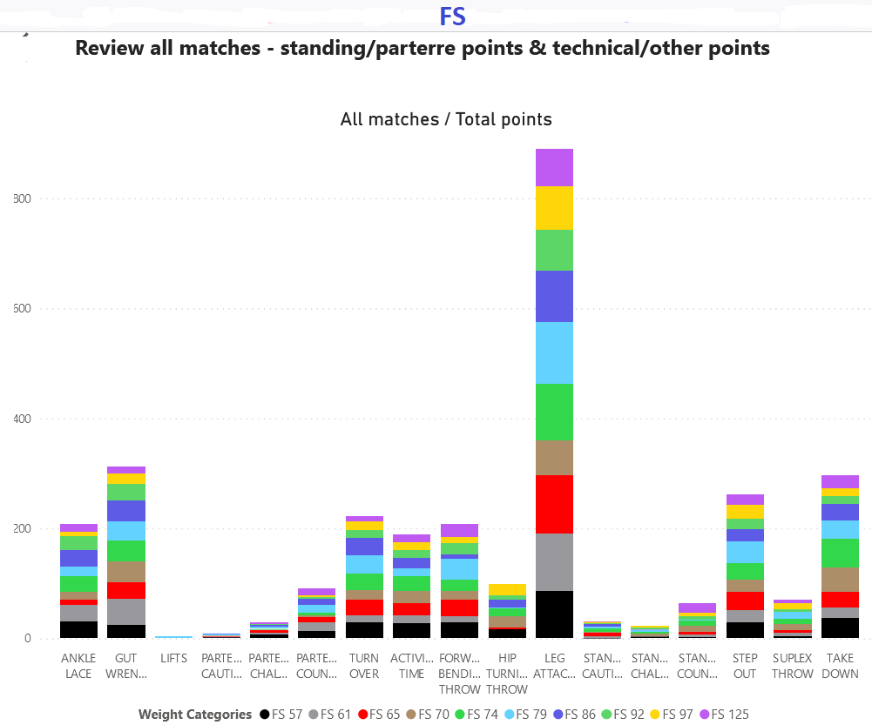 | In FS, the LEG ATACK technique scored the most points, 890 out of 3004 points or 29.63%. The most points were won in the 79 kg category - 112, then in the 65 kg category - 106 points and in the 61 kg category - 104 points.  The second technique with the number of points was the GUT WRENCH with 10.39% of points. The most points with this technique were scored in the 61 kg category - 48 points and in the 70 kg, 74 kg and 86 kg categories - 38 points.  The third technique in terms of points was TAKE DOWN with 9.85 points. The most points with this technique were scored in the category 74 kg - 52 points, 70 kg - 44 points and 57 kg - 36 points.
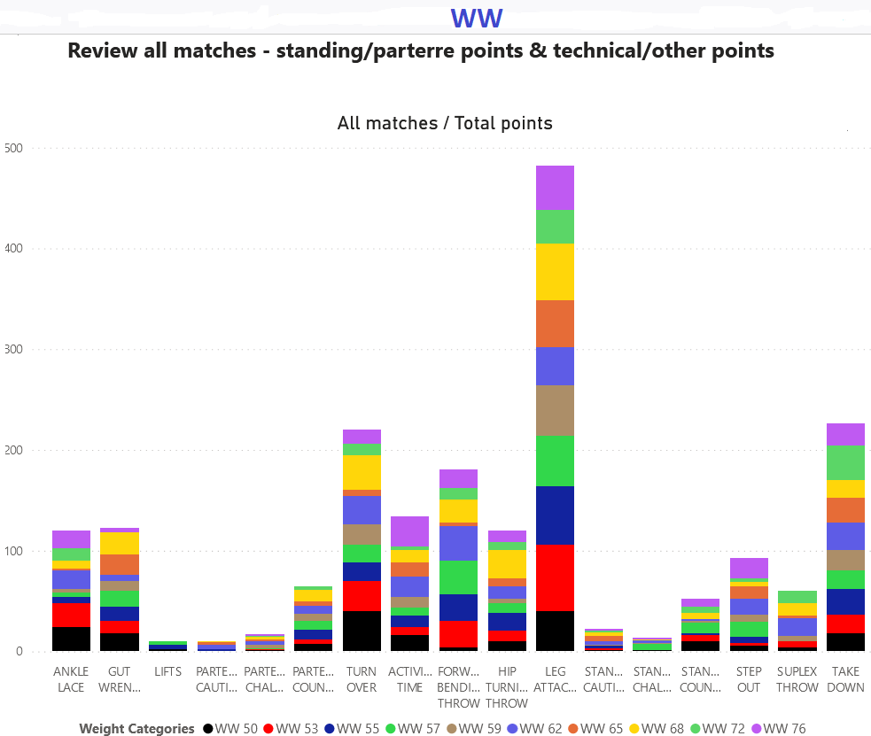 | In WW, the LEG ATACK technique scored the most points, 482 out of 1994 points or 24.79%. The most points were won in the category 53 kg - 66, then in 55 kg - 58 points and in 68 kg - 56 points.  The second technique by the number of points was TAKE DOWN with 11.63% of points. The most points with this technique were scored in the 72 kg category - 34 points, 62 kg - 28 points and 55 kg - 26 points.  The third technique by number of points was TURN OVER with 11.32 points. The most points with this technique were scored in the category 50 kg - 40 points, 68 kg - 34 points and 53 kg - 30 points.

5.1. GR - EFFICIENCY (WQ/min) & STANDING / PARTERRE IN % (PERCENTAGE)

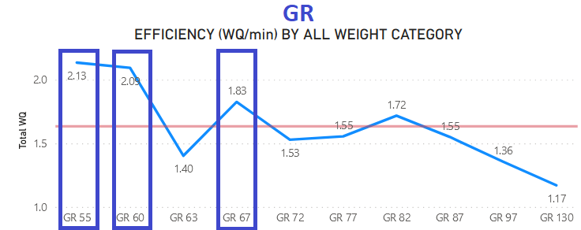 | One of the very important indicators of technical efficiency in wrestling matches is the number of points scored per one (1) minute of the match.  From the attached graph it is evident that the wrestlers in the lower weight categories are much more effective in the GR style. The first two weight categories stand out in particular: 55 kg and 60 kg, where the WQ/min is 2.13 and 2.09, respectively. The third most effective weight category is 67 kg with 1.83 points per minute of fighting.  By far the fewest points were made in the two heaviest categories, namely in 130 kg - 1.17 and 97 kg 1.36 points per minute of the fight.  The surprising result is in the 63 kg category, where WQ/min is 1.40.
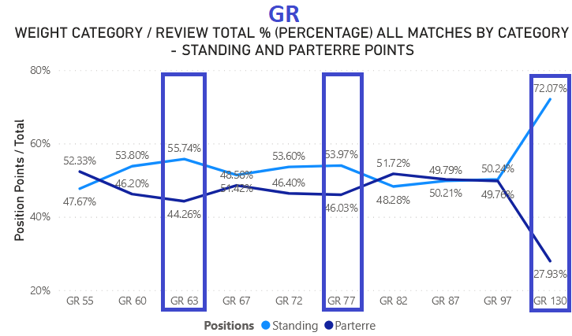 | This graph in GR style shows the ratio of standing and parterre points by weight category in GR style.  The biggest deviation from the average is visible in 130 kg, where the ratio of points is 72.07 - 27.93% in favor of points in standing.  In all other categories, the number of points is approximately the same in standing and parterre.  As can be seen in the attached graph, the greater number of points in the parterre are in three weight categories: 55 kg - 52.33%, 82 kg - 51.72% and 87 kg - 50.21%.
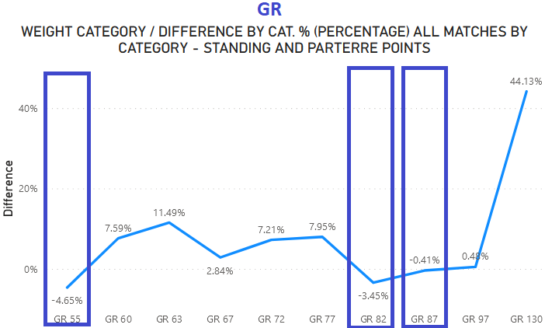 | This graph in GR style is directly related to the previous graph and provides data on the percentage difference between points won in standing and parterre.  The graph shows that the data in the 130 kg category differ significantly, where a much larger number of points were obtained in the standing position (the difference is 44.13%), because the dominant points are for passivity, take down and step out.  In all other categories, there is a very small difference in percentages between the points in the standing and parterrre positions and it ranges between plus / minus - 11% - 4%.

5.2. FS - EFFICIENCY (WQ/min) & STANDING / PARTERRE IN % (PERCENTAGE)

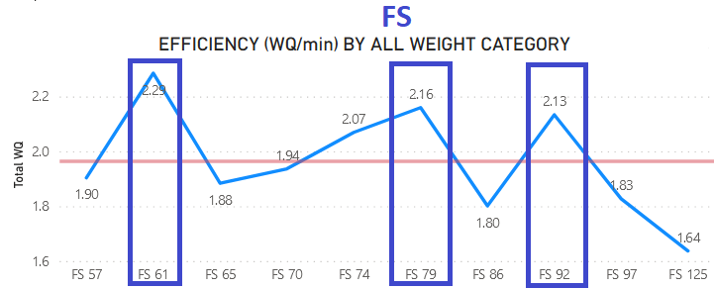 | Unlike the GR style where wrestlers in the lower weight categories were much more effective, in the FS style wrestlers from the middle weight categories (with the exception of 86 kg) were much more effective.  The most effective were the wrestlers in 61 kg with an index of 2.29 peons per minute of fight (WQ/min). In 79 kg, this index of efficiency is 2.16 points per minute of fight and in third place is 92 kg for an index of 2.13 points per minute of fight.  Very good results in FS, because even in 4 categories there were more than 2.0 points per minute of fight.  The fewest points were made in the heaviest category (125 kg) - 1.64 points per minute of fight, but if you compare the heavy category in GR style, where this index in 130 kg was - 1.17, then it is evident that the wrestlers are in the heavy category in FS were much more effective than heavyweight wrestlers in GR.
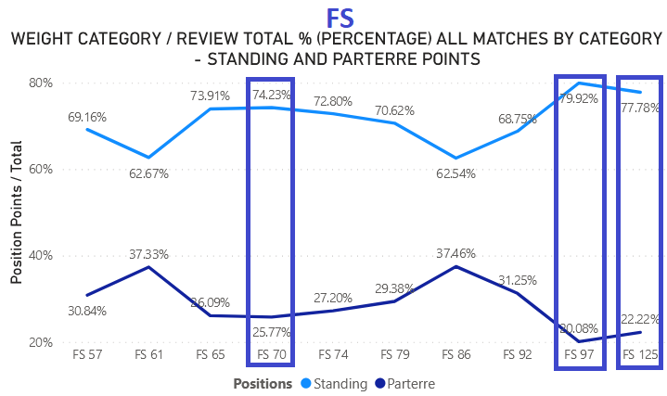 | This graph shows the ratio of points in standing and parterre by weight categories in FS style.  If you look at the curve by weight categories in GR and FS, it is clear that in FS there are many more points for techniques in standing, in all weight categories.  The graph is quite uniform in terms of values, and there are slightly more standing points in the categories: 97 kg, 125 kg and 70 kg.  As can be seen in the attached graph, a slightly higher number of points in the parterre are in two weight categories: 61 kg and 86 kg.
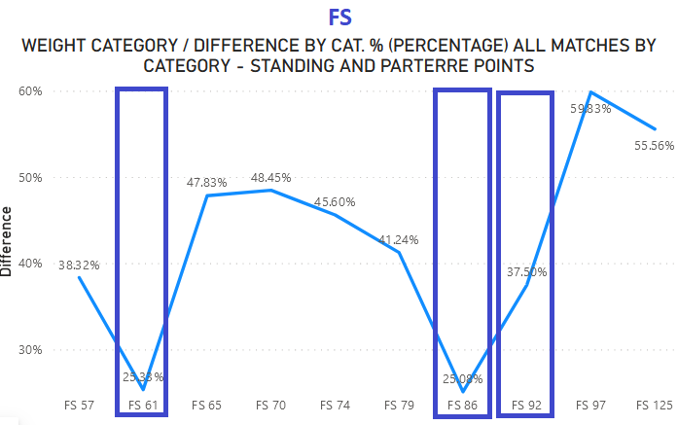 | This chart in FS is directly related to the previous chart and provides data on the percentage difference between points won in standing and parterre.  The graph shows that in three categories, a slightly higher percentage of points are in the parterre compared to the other weight categories - 86 kg, 61 kg and 92 kg.  In all other categories, there is a very big difference in percentages between peons in standing and parterre, and it ranges between plus / minus - 59% - 41%.

5.3. WW - EFFICIENCY (WQ/min) & STANDING / PARTERRE IN % (PERCENTAGE)

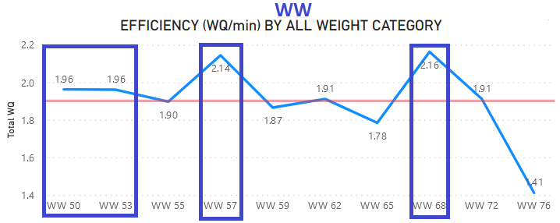 | In WW, female wrestlers were the most effective in two weight categories: 66 kg (2.16%) and 57 kg (2.14).  What is good about WW is that in as many as 7 weight categories there was an average of 1.90 or more points per minute of fight (WQ/min).  The fewest points were scored in the heaviest category (76 kg) – 1.41 points per minute of the fight. This is expected, because in the other two styles (GR, FS), the lowest number of points was made in heavy categories.
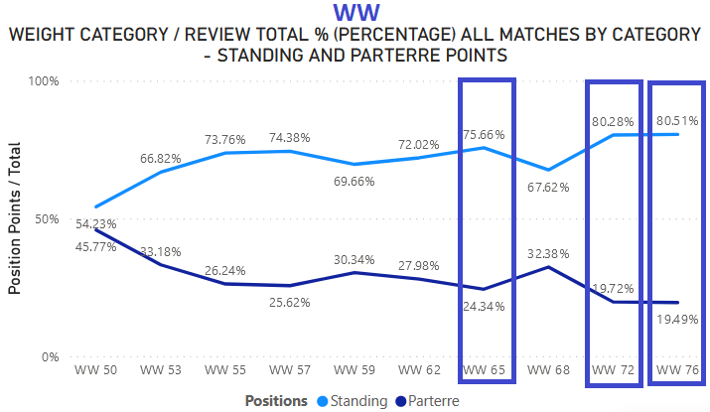 | This graph shows the ratio of standing and parterre points by weight class in WW style.  If you look at the curve by weight category in GR and FS, it is visible that the results are similar in WW and FS, but it is significantly different from the results in GR style.  The graph is quite uniform in terms of values, and differs slightly with more parterre points in the category: 50 kg (45.77%).  As can be seen in the attached graph, there is a slightly higher number of points in standing (more than 80%) in two weight categories: 72 kg and 76 kg. In all other categories, the number of points in the standings is around 70%.
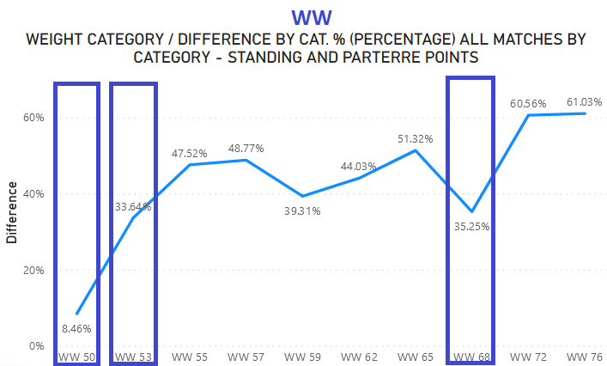 | This graph in WW is directly related to the previous graph and provides data on the percentage difference between points won in standing and parterre.  The graph shows that in three weight categories, a slightly higher percentage of points are in the parterre position compared to the other weight categories - 50 kg, 53 kg and 68 kg.  In all other weight categories, there is a very big difference in percentages between points in standing and parterre, and it ranges between plus / minus - 61% - 40%.

6. REVIEW TOTAL % (PERCENTAGE) BY CATEGORY – TECNICAL AND OTHER POINTS / GR-FS-WW

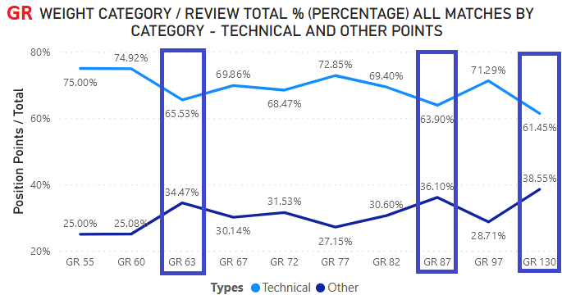 | This is one of the more significant analyzes that shows the relationship between points given for performed wrestling techniques and points that are not technical points, namely: passivity, step out, challenge, caution. In the GR style, there were a total of 30.46% of points that were not the result of performed wrestling techniques.  In recent years, in the GR style, there is a very high percentage of other points, and this is not good for the image of wrestling, because the referees often have to decide the winner of the match with their decisions (passivity).  In three weight categories, the number of other points is greater than 1/3, namely: 130 kg - 38.55%, 87 kg - 36.10% and 63 kg - 34.47%.  The least other points were in the categories 55 kg and 60 kg - 25%, but even that is a large number, because it is 1/4 of the total number of points in the matches in the GR style of wrestling.
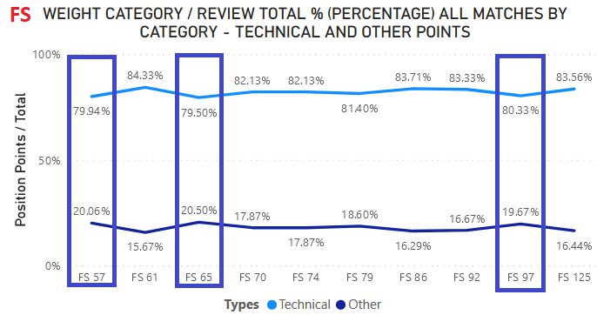 | FS matches have much better indicators when it comes to other points compared to GR style. In the FS style, there were a total of 18.04% of points that were not the result of performed wrestling techniques.  Only two categories are above 20% of other points, namely: 65 kg - 20.50% and 57 kg - 20.06%. In all other categories, this percentage is below 20%.  The least other points were in 61 kg - 15.67%, 86 kg - 16.69% and 125 kg - 16.44%.
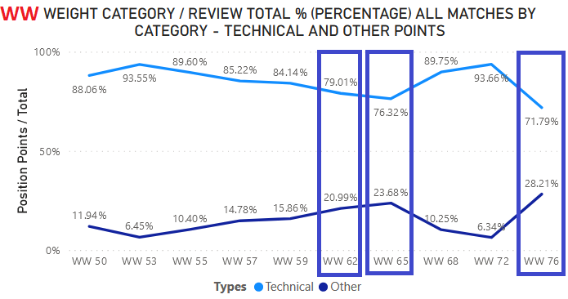 | WW matches have much better indicators when it comes to other points compared to GR style and FS.  In WW, there were a total of 14.81% points that were not the result of performed wrestling techniques.  Points above 20% remained in three weight categories: 76 kg - 28.21%, 65 kg - 23.68% and 62 kg - 20.99%. In all other categories, this percentage is significantly below 20%.  The least other points were in 72 kg - 6.34% and 53 kg - 6.45. Matches in these two categories are a good example, where there are few other points, and a large number of points were awarded for the wrestling techniques performed.

7. MOST SUCCESSFUL WRESTLER (MSW) / GR-FS-WW

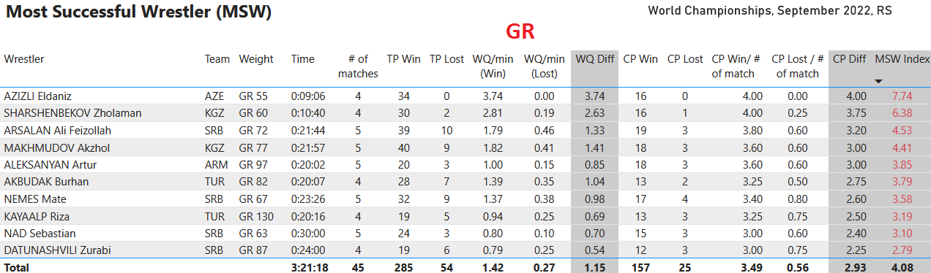
The most successful wrestler in the GR style was AZIZLI ELDANIZ in 55 kg, who won 34 technical points, and not a single opponent managed to score a single point on him. When penalized, Azizli had 16 classification points and 0 lost classification points in 4 matches. These results put him at the top of the most successful GR wrestlers at WCH 2022.
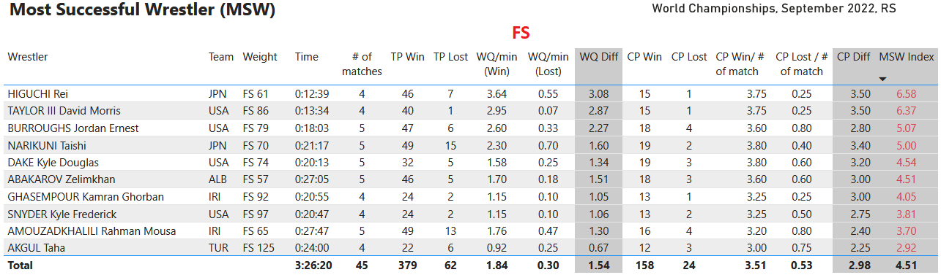
The most successful wrestler in the FS style was HIGUCHI REI in 61 kg, who won 46 technical points and lost 7 points. Higuchi had 4 matches in which he received 15 classification points and only one minus classification point. Mostly because of the high number of points won (46) in 4 matches, they put him in the first place of the most successful wrestlers in FS style at WCH 2022.
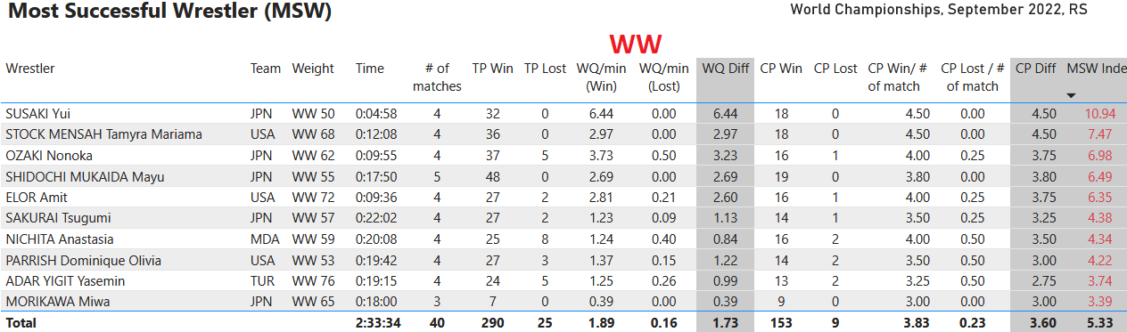
The most successful wrestler in WW was SUSAAKI YUI in 50 kg, who won 32 technical points, and not a single opponent managed to score a single point on her. In 4 matches, Susaki had as many as 18 classification points, and not a single lost classification point. These results put her at the top of the top female wrestlers in WW at WCH 2022.

8. NATIONAL TEAM PERFORMACE / POINTS WIN and POINTS LOST / GR-FS-WW

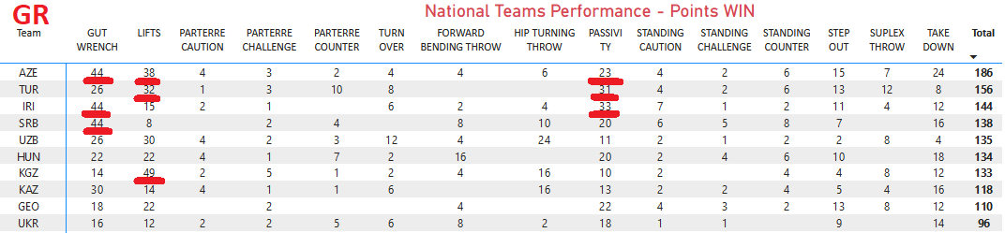

To display the results according to this parameter from this 2022 World Championship, an overview of the first 10 nations by the number of points won and lost is given.
The points won by national teams were analyzed in GR style. From this table it can be seen that out of the 3 techniques, with the most points, Azerbaijan wrestlers are among the best in all three wrestling techniques (gut wrench, lifts and passivity). The Turkish national team is very good in lifts and passivity. Iran in the technique of gut wrench and passivity. The teams of Serbia (gut wrench) and Kyrgyzstan stand out due to a significant number of points in technique - lifts.
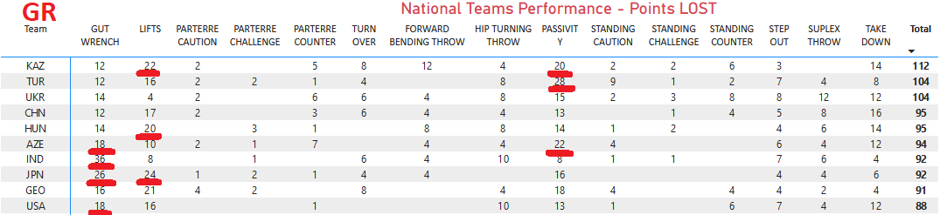
In the table of national teams that lost the most points in GR style, the following national teams stand out: Kazakhstan, which lost a lot of points on lifts and passivity, Japan in gut wrench and lifts techniques. Azerbaijan scores poorly in gut wrench and passivity. Japan in gut wrench and lifts. According to one criterion, the following had bad results: Turkey in passivity, Hungary in lifts, India in gut wrench and the USA in gut wrench.

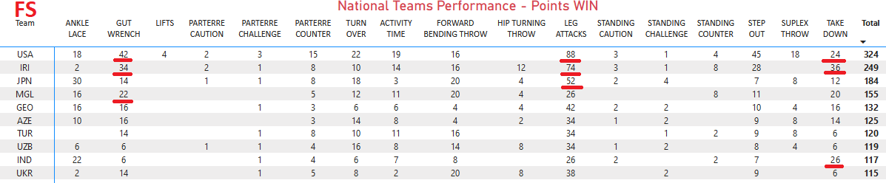
In FS style, the points won by national teams were analyzed. From this table it can be seen that of the 3 techniques that are performed the most (with the most points), in all 3 techniques the best wrestlers are the USA and Iran (leg attacks, gut wrench and take down). The national team of Japan is very good in leg attack, Mongolia in gut wrench and India in take down.
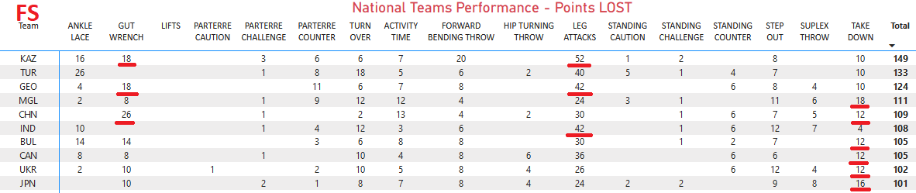
In the table of national teams that lost the most points in FS, the following national teams stand out: Kazakhstan, which lost a lot of points on gut wrench and leg attacks, Georgia in gut wrench and leg attacks, China in gut wrench and take down techniques. According to one criterion, bad results were obtained by: Mongolia in take down, India in leg attacks, Bulgaria, Canada, Ukraine and Japan in take down.

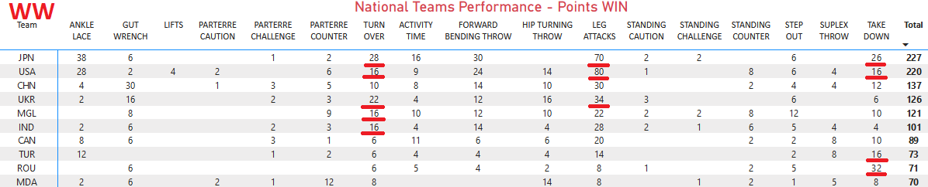
In WW style, points won by national teams were analyzed. From this table, it can be seen that of the 3 techniques that are performed the most (with the most points), in all 3 techniques the best female wrestlers are from Japan and the USA (leg attacks, turn ower and take down). The Ukrainian national team has many points in techniques: leg attacks and turn over. The national teams of Mongolia and India are good in turn over, and Turkey and Romania are good in take down.
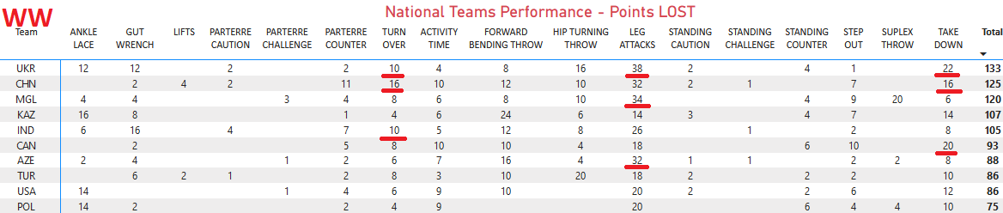
In the table of national teams that lost the most points in WW, the national team of Ukraine has bad results in all three techniques, i.e. many lost points (leg attacks, take down, turn over). China has a lot of lost points turn over and take down. According to one criterion, bad results were obtained by: India in turn over, Canada in take down and Azerbaijan in leg attacks.

9. INDIVIDUAL WRESTLERS PERFORMANCE – GR-FS-WW/ POINTS WIN – POINTS LOST

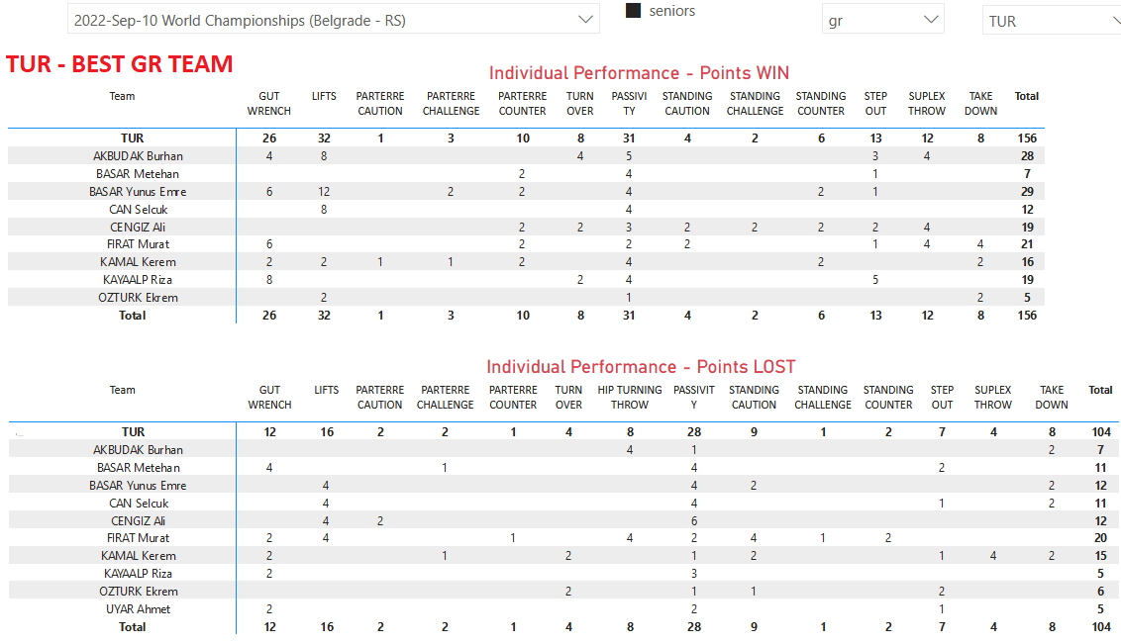
To present this analysis, the best national selection in team scoring was selected. Turkey was the most successful in the GR style. For each wrestler, points are shown by wrestling techniques won by each wrestler in the team. Likewise, for each wrestler, points lost by wrestling techniques are shown. Wrestlers are listed alphabetically. Basar Emre (29) and Akbudak Burhan (28) scored the most points in the Turkish team. Both wrestlers had the most points won by technique - lifts. Firat Murat (20) and Kamal Karem (15) lost the most points.

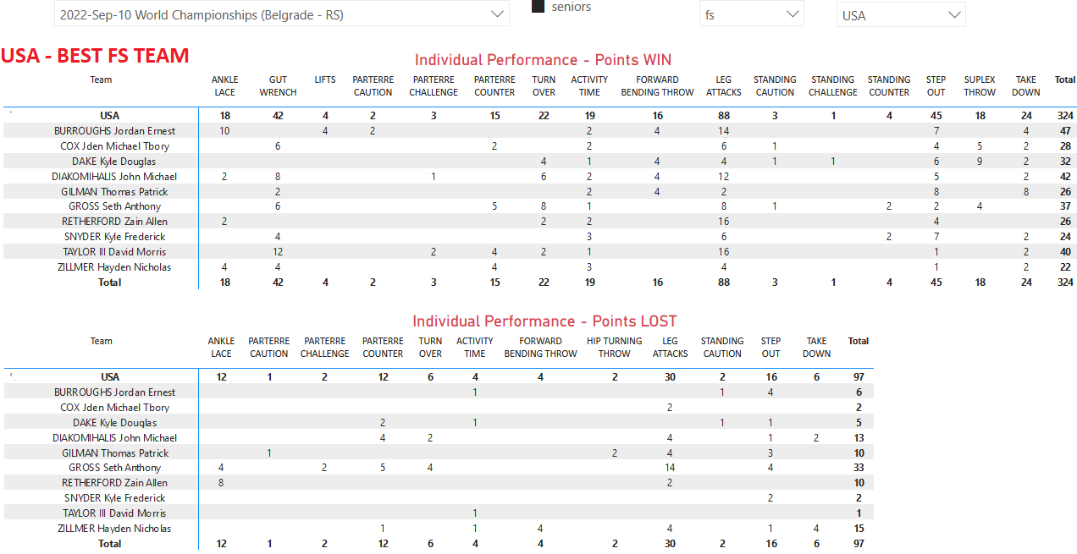

USA was the most successful in the FS style. For each wrestler, points are shown by wrestling techniques won by each wrestler in the team. Likewise, for each wrestler, loss points by wrestling techniques are shown. Wrestlers are listed alphabetically. In the USA team, more than 40 points were won by wrestlers: Burroughs Ernest (47), Diakomihaus Michael (42) and Taylor III Morris (40). All three wrestlers had the most points won by technique - leg attacks. The most points were lost by Gross Anthony (33 ) of which even 14 points – leg attack.

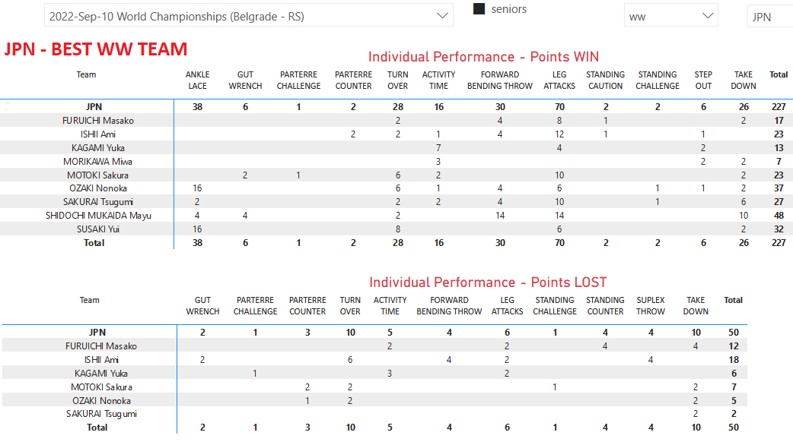
The Japanese team was the most successful in the WW style. For each female wrestler, the points by wrestling techniques won by each female wrestler on the team are shown. Likewise, for each female wrestler, losing points by wrestling techniques are shown. Female wrestlers are listed alphabetically. In the Japanese team, more than 30 points were won by female wrestlers: Shidochi Mayu (48), Ozaki Nonoka (37) and Susaki Yui (32). The most points for wrestling techniques were: Shidochi Mayu (leg attacks and forward bedding throw), Ozaki Nonoka (ankle lace) and Susaki Yui (ankle lace). Ishe Ami (18) and Furruichi Masako (12) lost the most points.

FINAL CONSIDERATIONS
In the limited space required by scientific work for the purposes of UWW, it is impossible to display all the data contained in the Performance Data Analysis (PDA). All data can be found in 34 tables and 29 graphs, with numerous exact data for each segment of the wrestling match, namely:
- Basic information about matches,
- Review all matches – standing/parterre points & tecnical/other points
- Review by weighting category – standing/parterre points and WQ/min,
- Review by weighting category – technical/other points and WQ/min,
- Review per national team – basic data (standing/parterre – technical/other points – WQ/min),
- National Teams Performance – Points WIN / National teams – Points LOST / National teams,
- Review medal matches (I-II, III-V),
- Most Successful Wrestler (MSW),
- Review of % points „All Matches“, „Medal“ matches (Finalist 1-2, 3-5) and all matches of „Winner’s (Gold medalists)“,
- Review time making points per minute (all matches),
- Best iwrestlers per Technics,
- Technics per all wrestlers „WIN“ and LOST“
This analysis shows the most important parts of the analysis in all three Olympic styles: GR, FS and WW. Based on the displayed results, wrestling coaches should draw the necessary conclusions for each analyzed segment and, based on that, correct their plans and programs in the following period, and based on the displayed data on the PDA platform –
( http://uww.io/wpar ).
Based on the success rate of each wrestler (champion), in the future the Burae UWW should introduce a rule that in the senior competitions of MSW, the wrestler is declared as the most successful wrestler and a prize money is provided for the most successful wrestler by style. In the junior age group competitions, it would be good to award a trophy to be awarded to the most successful wrestler in each style.
In the future, the PDA should be of great use to scientists, who can create many scientific works based on the data from the PDA. A very large number of scientific works should be done according to the principle of comparative analysis of one or more wrestling competitions. It is planned to make analyzes in PDA this year, for all major competitions that were held in the period 2020 - 2023. When all the analyzes are finished, the work of scientific workers will be significantly facilitated in the preparation of various types of scientific papers.

REFERENCES
- Internet platforma UWW – PDA – Senior World Championship 2022. Belgrad (SRB) - ( http://uww.io/wpar )

